Pre-requites:

1. Create a ServiceNow developer account free
2. Request instance in <https://developer.servicenow.com/dev.do#!/home>
3. 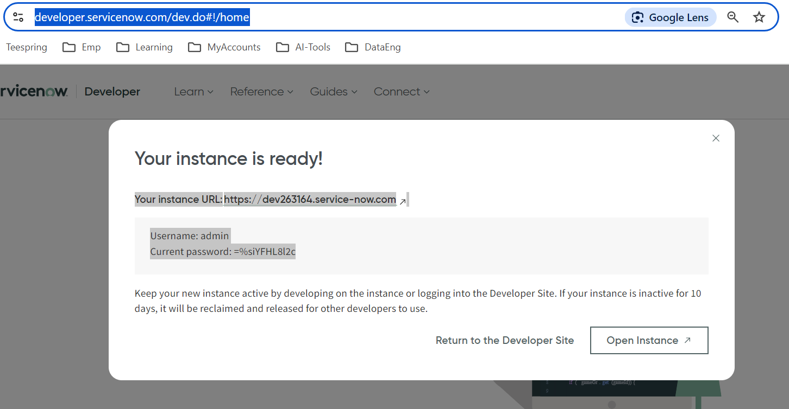
4. Copy and paste somewhere in the local
5. Click On open instance for ServiceNow dashboard
6. In Dashboard select All > filter for Application Registry to create (client id and client secret)

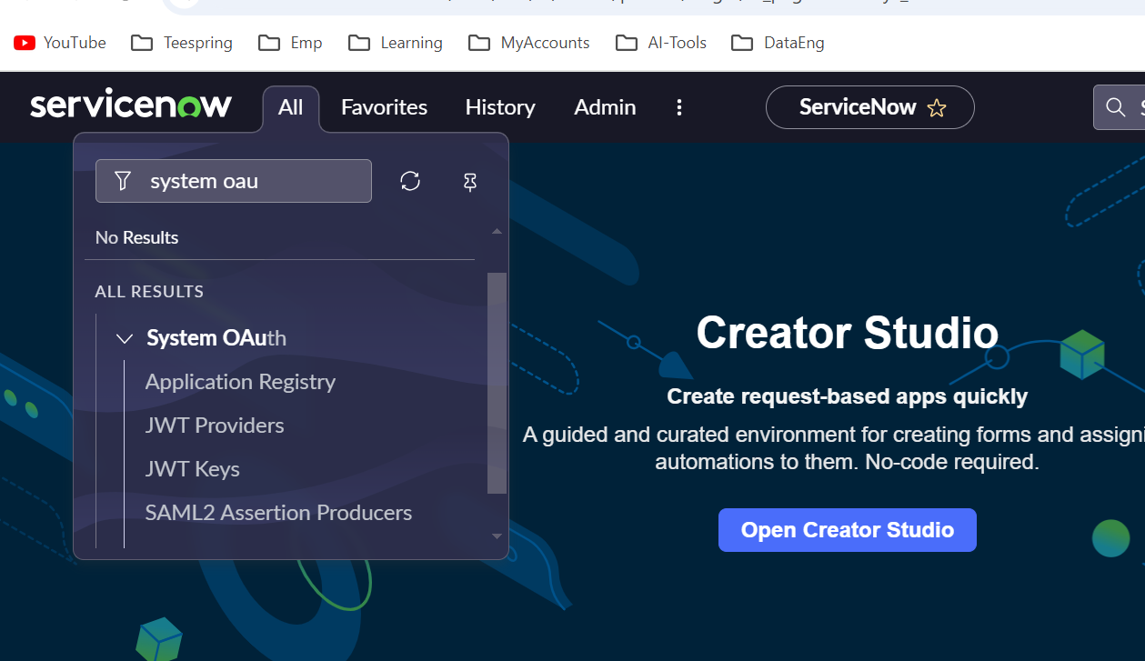

1. Click on “New” on the right corner
2. Select Create an OAuth API endpoint for external clients

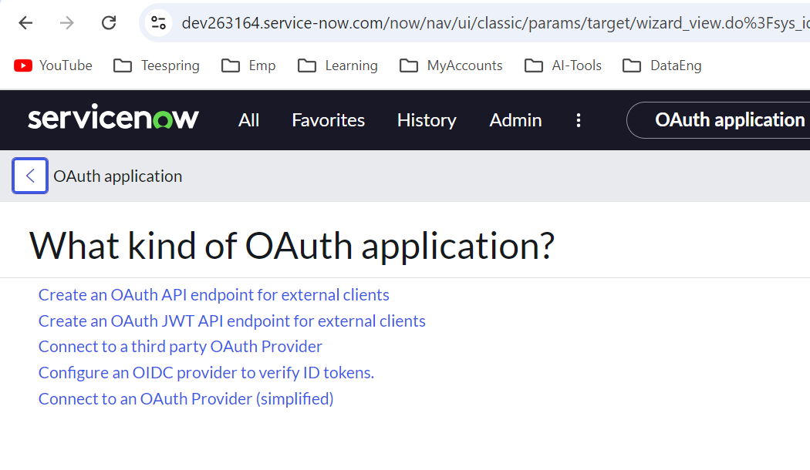

1. Enter the details as per the integration/Application

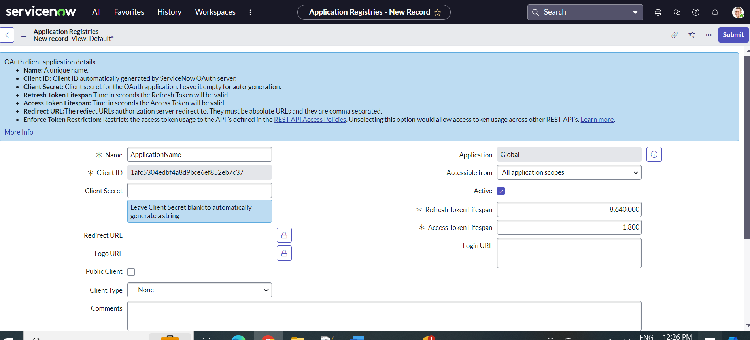

Client ID and client secret will be generated automatically

1. We can create groups and users in ServiceNow